1. 
2. We will continue with WorkLoad Modelling which is popularly known as **WLM** (**W**ork**L**oad **M**odelling)
3. Work Load related data is collected only for Peak Hour.
4. **Interview Question**:
   1. Where are you involved in WLM?
5. In last lecture, we discussed that we have to collect Workload related data.
6. Just assume that the following is workload related data.

Just see the slide and we will discuss about it.  
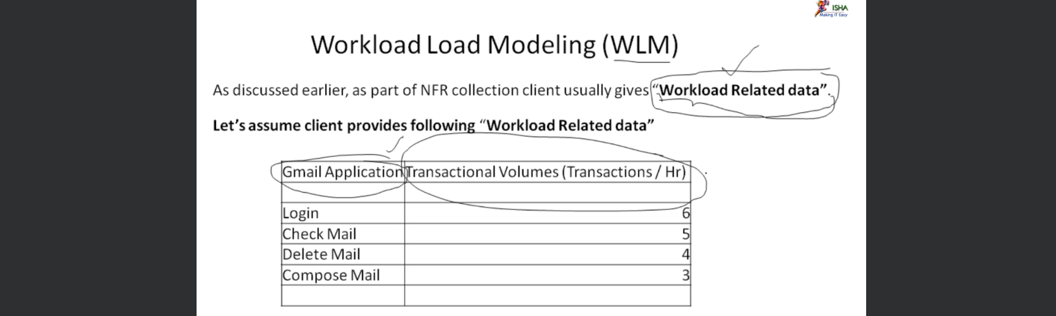

* 1. As per the WorkLoad Related data in the above slide,   
     6 transactions will happen in one Hour.  
     5 transactions for check mail in one hour and so on.  
     **NOTE**: The load is less as per second column and it is not a PT but for example purpose, we have taken it.

* 1. For the time being we will do Workload Modelling for Login Transaction / Business Process.
  2. 1st the Performance Tester will a Login Script.
  3. What does this Login Script contain or business process contain.  
     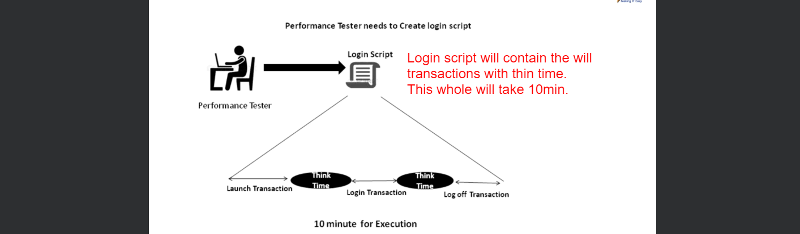  
     The above login script contains three transactions 🡺
     1. Launch Transaction.
     2. Login Transaction.
     3. Log off Transaction.  
        The login script will take 10min.
     4. As per WorkLoad related data given above, we want to perform 6 login transactions in one hour (Peak Load).
  4. 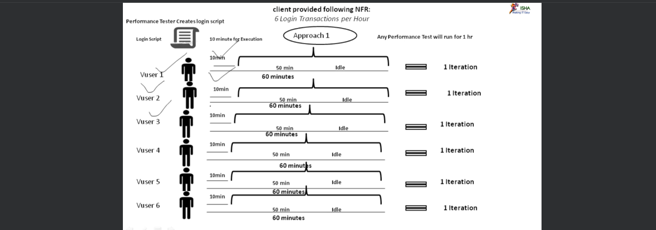  
     In the above diagram, we can see the execution of login Script.   
     Each Virtual User starts the script which will take 10min and for the remaining time, it will sit ideal.
  5. This is one approach to execute script. There is another approach too.
  6. Let us see in next lecture.